Release Pipeline Steps to deploy using Terraform

-------------------------------------------------------------

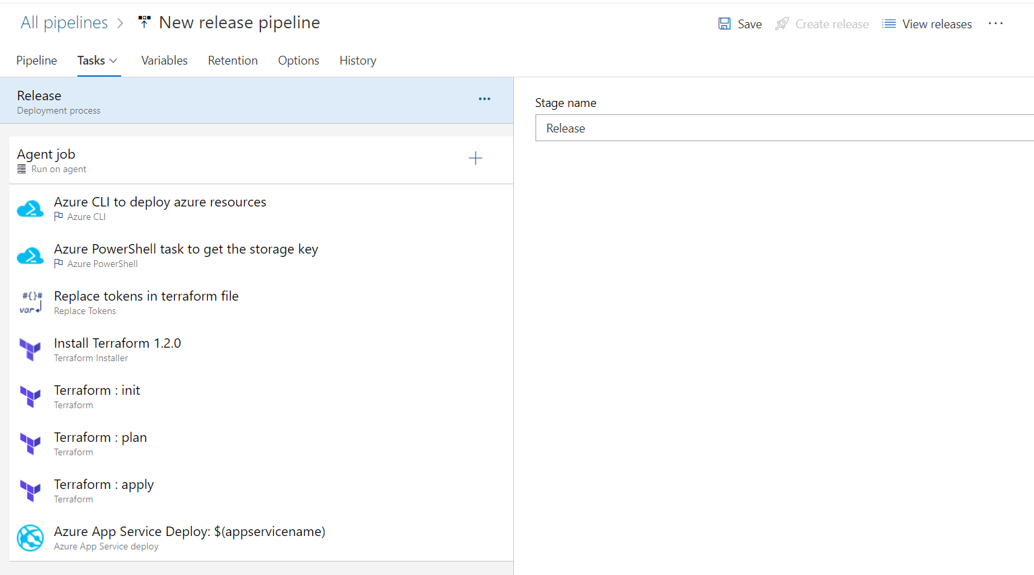

Task-1

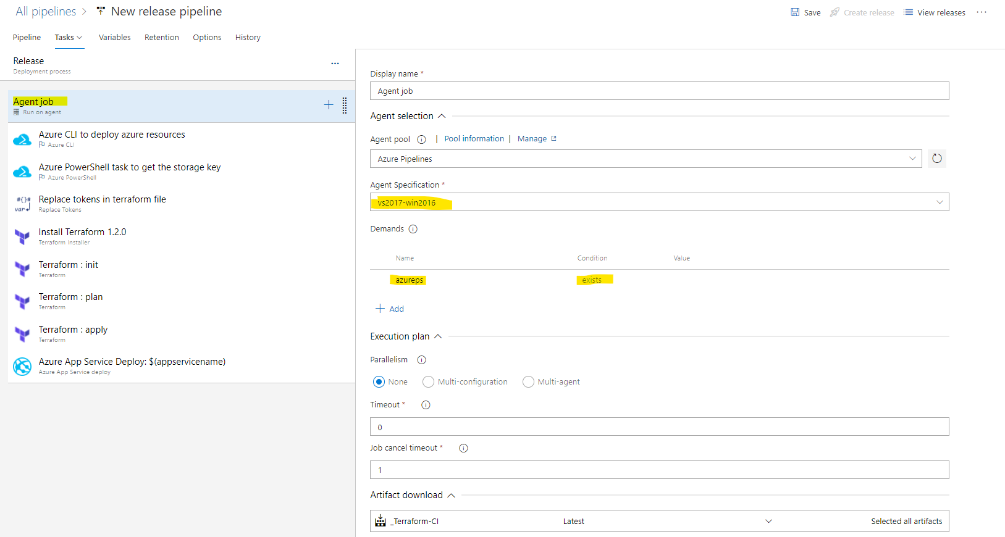

Task-2

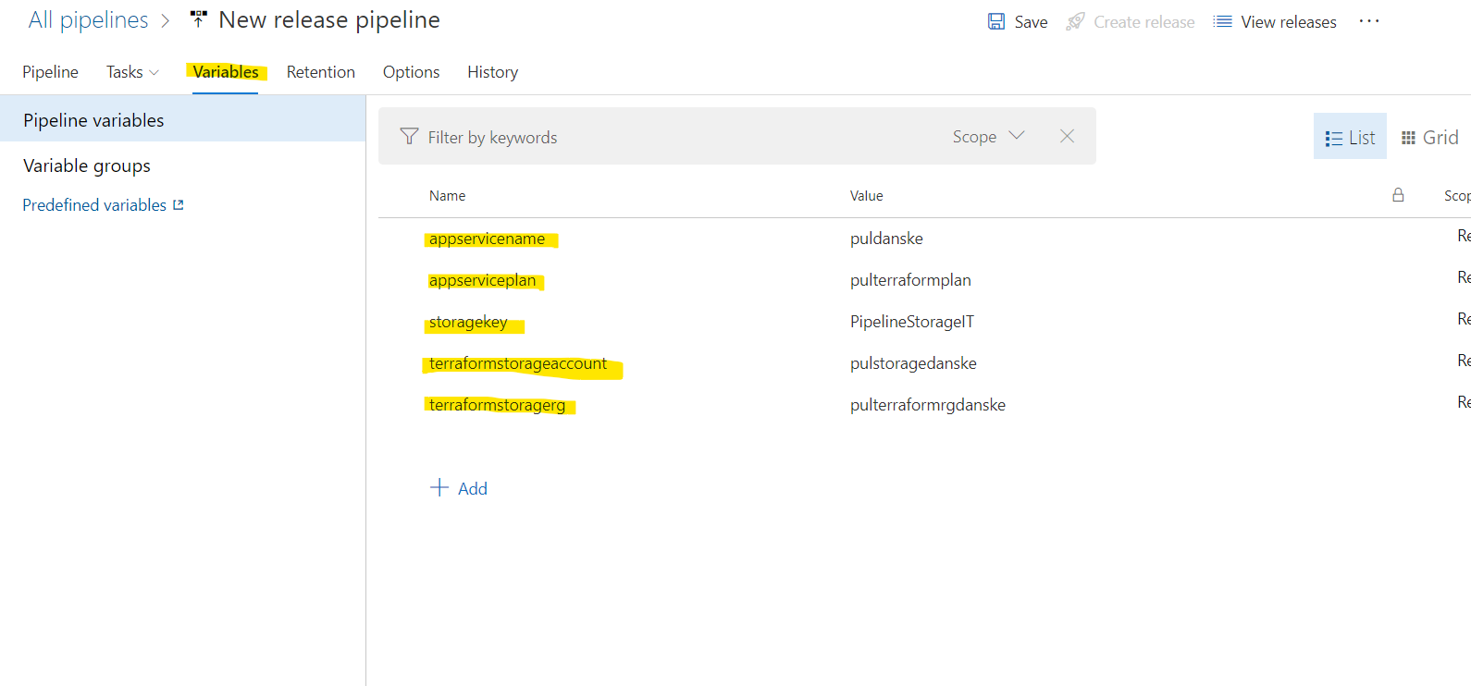

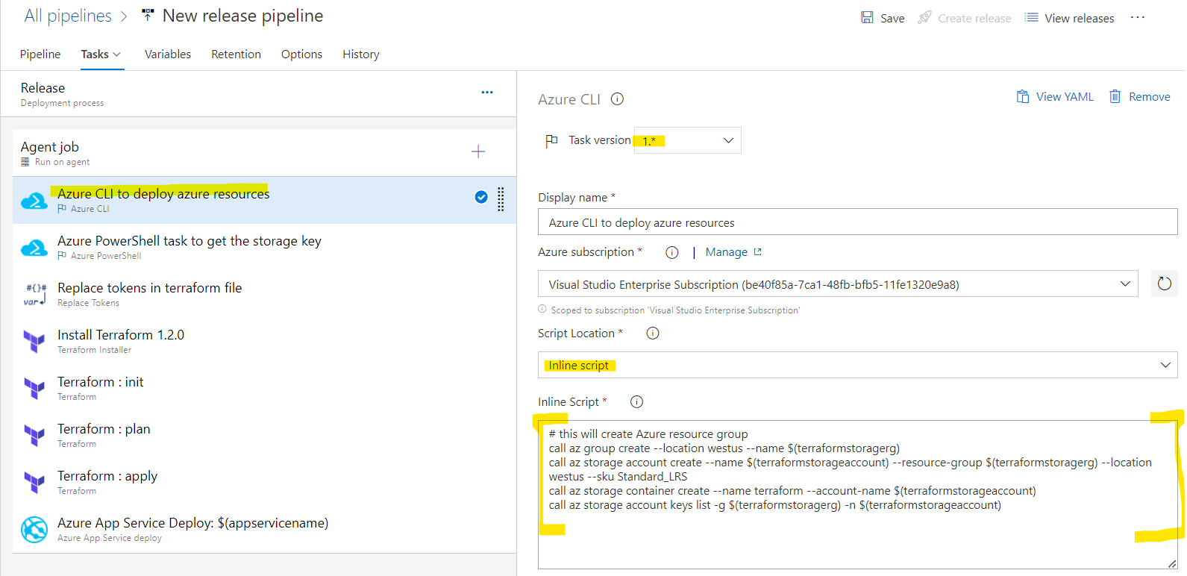

Inline Script

# this will create Azure resource group

call az group create --location westus --name $(terraformstoragerg)

call az storage account create --name $(terraformstorageaccount) --resource-group $(terraformstoragerg) --location westus --sku Standard_LRS

call az storage container create --name terraform --account-name $(terraformstorageaccount)

call az storage account keys list -g $(terraformstoragerg) -n $(terraformstorageaccount)

Task-3

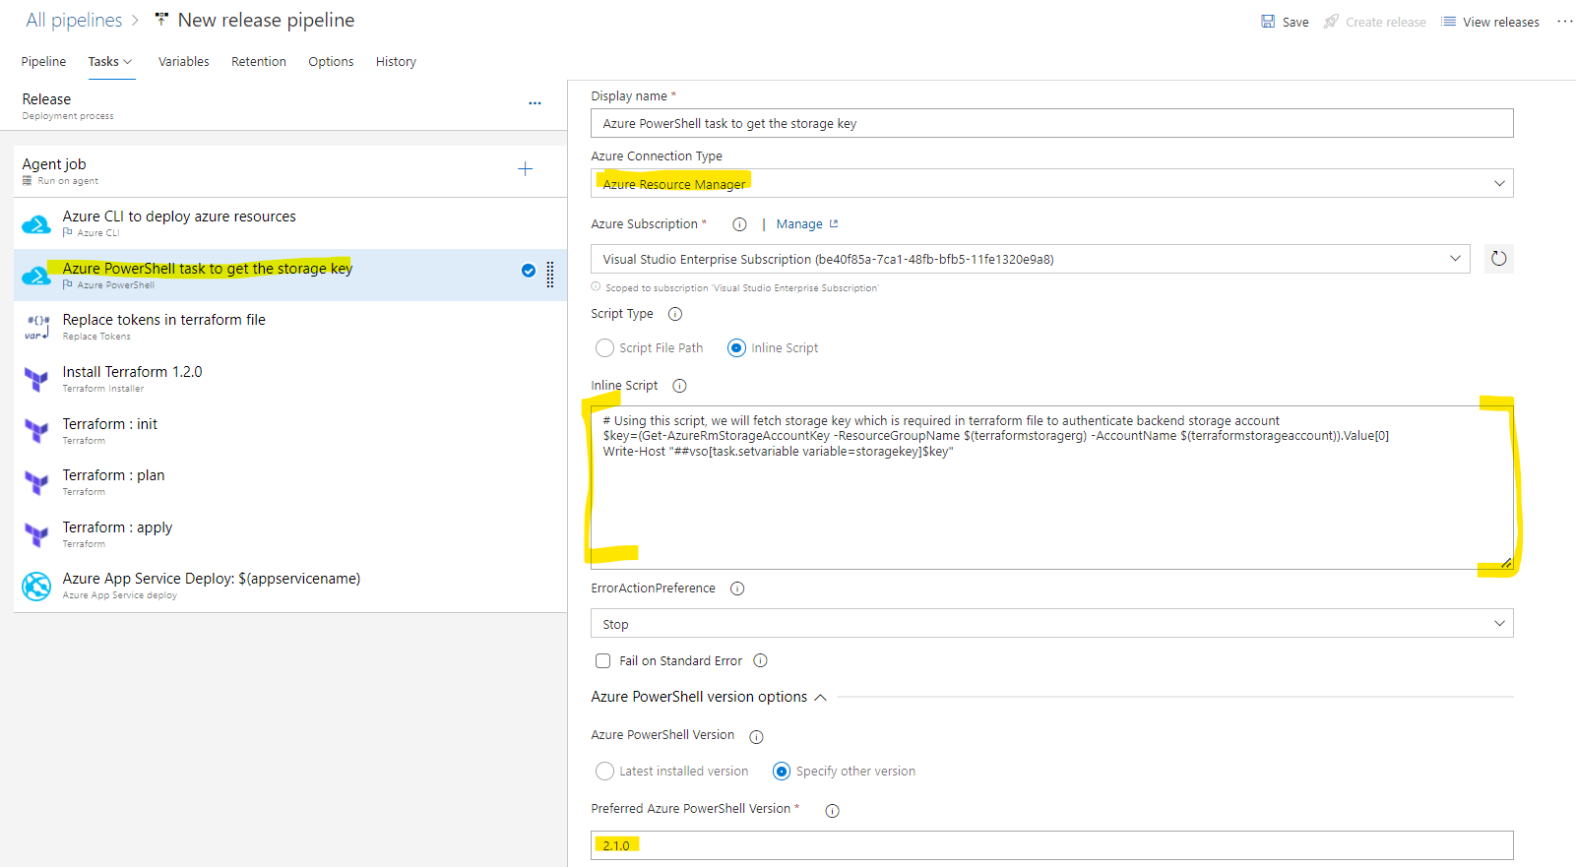

Inline Script

# Using this script, we will fetch storage key which is required in terraform file to authenticate backend storage account

$key=(Get-AzureRmStorageAccountKey -ResourceGroupName $(terraformstoragerg) -AccountName $(terraformstorageaccount)).Value[0]

Write-Host "##vso[task.setvariable variable=storagekey]$key"

Task-4

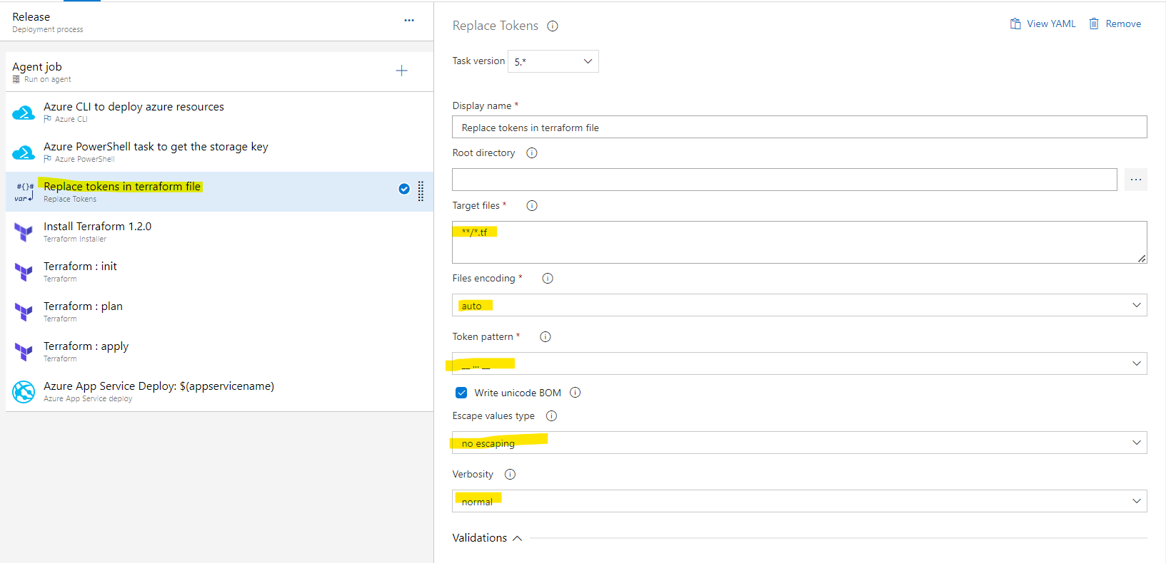

Task-5

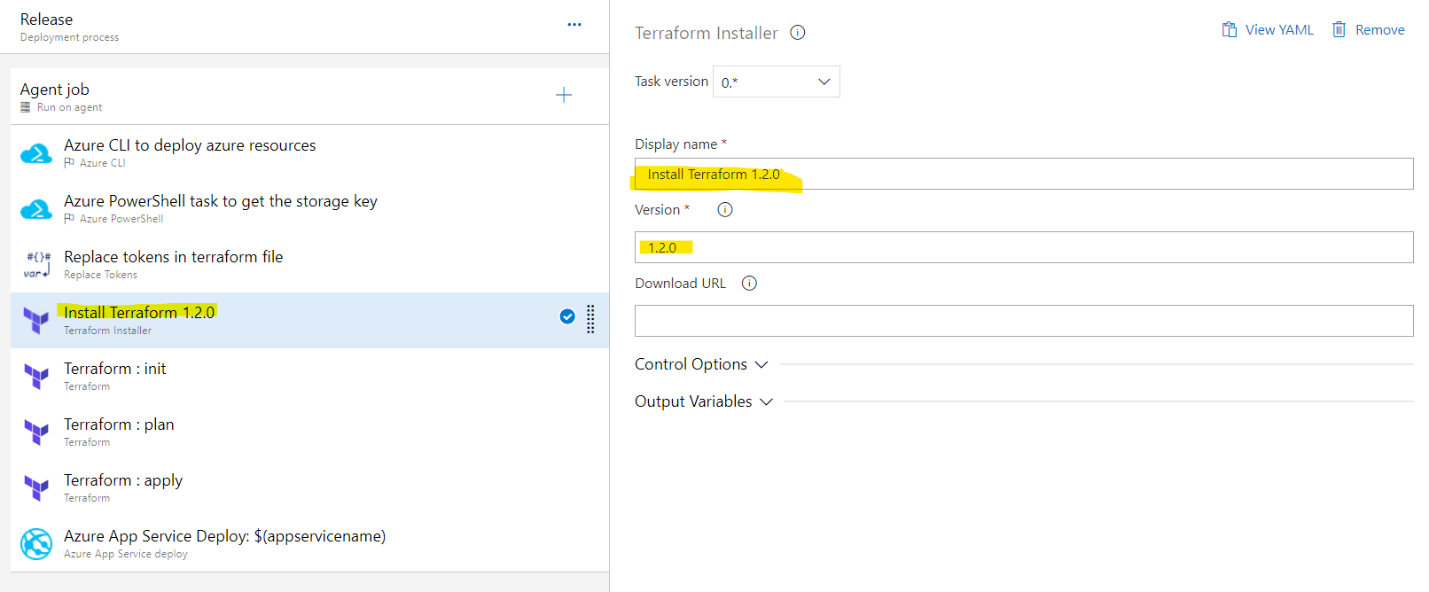

Task-6

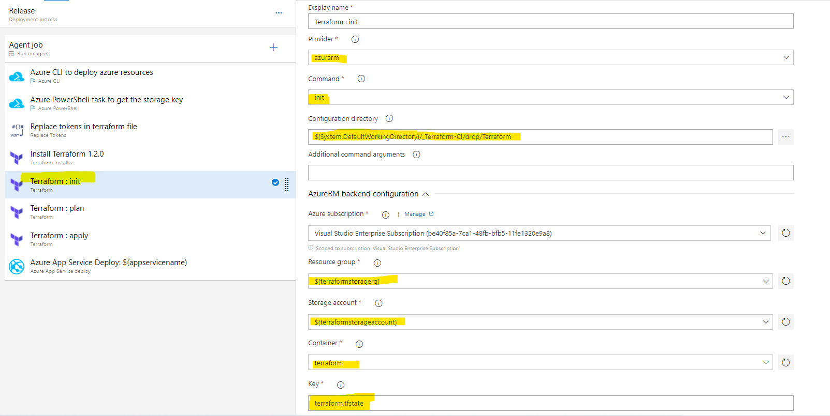

Configuration directory

$(System.DefaultWorkingDirectory)/_Terraform-CI/drop/Terraform

Task-7

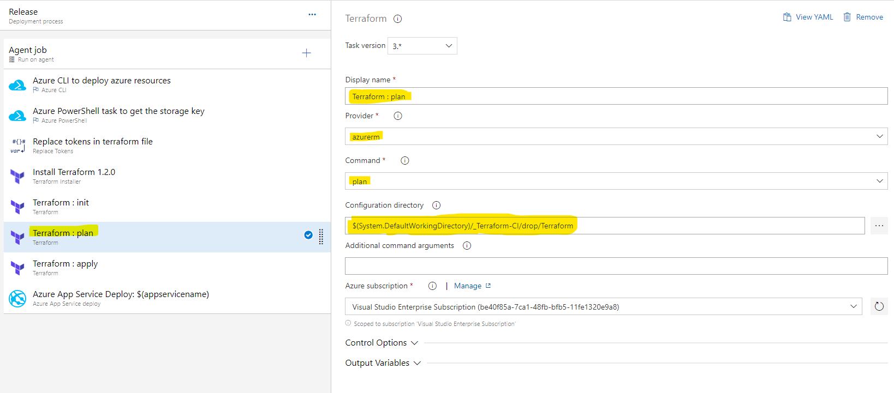

Task-8

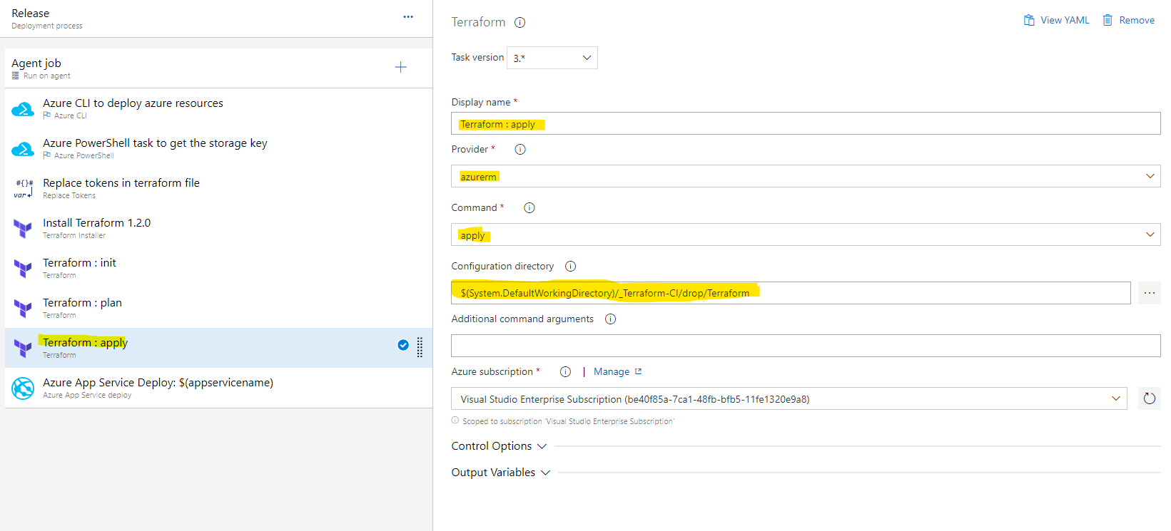

Task-9

